**User Manual (CS Group 3)**

l **Operating environment requirements**

**1. Operating system: Windows/Linux/Mac OS**

**2. Compiler: Visual Studio Code (Version: 1.84.2 (Universal))**

**3. Software package management system ：npm (Version 9.5.1)**

**4. Server running environment : Django (Version: 3.1.12), Django REST framework (Version: 3.12.4)**

**5. Database: MongoDB (connect through djongo)**

l **Developer Installation Guide**

**1. Download**

Download our code from <https://github.com/david188888/Soulwhisper> and save them to a directory or drive location that is easily accessible for subsequent use.

**2. Load page**

2.1 Open a new terminal, enter "cd backend" to navigate to the backend folder, and enter "pip install -r requiremments" to install the required modules.

2.2 Connect to the database. In MongoDB Compass, create a new database and name it "soulwhisper". Then, in the terminal of Visual Studio Code, enter the two commands "python manage.py makemmigrations" and "pythonmanage.py migrate".

2.3 Start our backend. You can enter the two commands "cd backend" and "python manage.py runserver"

2.4 Authenticate as a developer in unicloud. For details, see <https://unicloud.dcloud.net.cn>, then return to HBuilderX and enable the cloud service space.

2.5 In HBuilderX, choose to open in the built-in browser. The built-in browser in HBuilderX can emulate our APP on a mobile phone and supports multiple device models.

2.6 Click parse button and you can see the login page, which means you start our app successfully.

l **App Installation Guide (For user)**

Download our installation package SoulWhisper.apk, then tap on our app icon (shown in Figure 1).



Figure 1: Our App icon

Next, we will continue introducing the pages to you.

l **The Introduction of our pages**

1. **Login and registration page:**

This page is a simple and elegant user registration and login interface. It supports new user registration and existing user login. The interface style is primarily purple, with simple and intuitive operations.

1. **Home page:**

This is the homepage of the SoulWhisper APP. It provides users with daily lucky keyword recommendations, displays healing phrases and healing activities, and offers quick access to voice recordings, drift bottles, and AI chat. It also integrates an emotion calendar, making it convenient for users to track their diaries and manage daily moods. The page is clean and intuitive, with easy operations.

**3. AI emotional communication page:**

This page is the AI psychological companion chat interface, where users can engage in psychological consultation, emotional expression, and communication with the AI to receive emotional support and companionship. The interface is clean, supports free input and instant replies, helping users to relieve emotions and express themselves.

**4. Statistics page:**

This page provides the weekly emotion report, displaying the user's emotional keyword cloud and emotion distribution pie chart for the week. It helps users intuitively understand their recent emotional state and keyword trends, facilitating emotional self-management and reflection.

1. **Record page:**

This page offers voice recording. Users can record audio by clicking a button, with the recording duration displayed in real-time, making it easy to capture and express current emotions and thoughts.

1. **Diary page:**

This page supports diary editing and publishing. Users can enter text content and add photos or videos. Once editing is complete, the diary can be published with one click, making it convenient to record and share daily moods and life moments.

1. **Comment page:**

This page is the Mood Square, where users can browse, categorize, and favorite various articles and posts related to emotional management and personal growth. It provides methods for emotional regulation and psychological support, promoting self-growth and communication.

1. **Profile page:**

This page is used to display the user's basic information. It allows users to change their name, view their own diary entries, likes, and comment data. Users can also access basic information about the APP.

l **Operate Instructions**

1. **Register and Login**

When users first enter our APP, they land on the login page (Figure 2). Returning users can log in directly, while new users need to click “Register Now” to sign up. On the SoulWhisper registration page (Figure 1), users can easily create their own account.

First, after entering the registration interface, you need to fill in your username and password, then confirm the password again to ensure accuracy. Next, select your gender (options include “Male,” “Female,” or “Other”). Once all information is filled out, simply click the prominent purple “register” button at the bottom to complete the registration.

After registering, click the “Login now!” link at the bottom of the page to return to the login interface. Enter your newly created account and password to begin your journey of mood management!

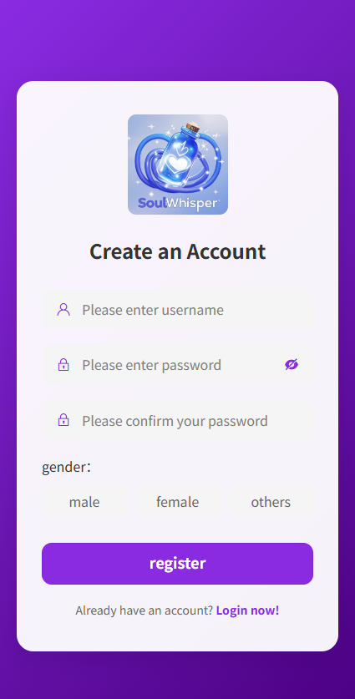 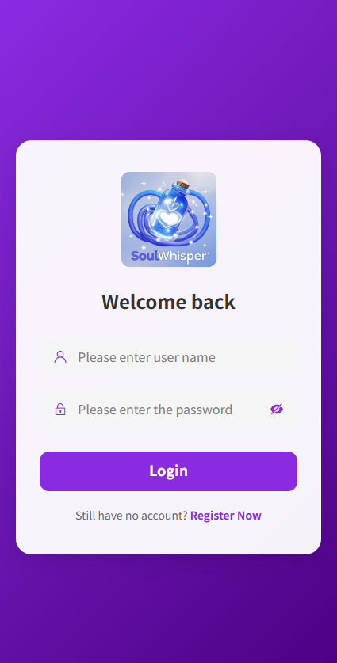

Figure 2 Register Page Figure 3 Login Page

1. **Homepage**

After successfully logging in, you will be taken to the SoulWhisper homepage. At the top of the homepage, the system will recommend a daily lucky keyword along with a healing quote and a suggested healing activity to help you start your day with positivity. Below, there are three quick access options: "New Record" allows you to quickly record and save a voice diary, "Message Bottle" lets you send or receive anonymous emotional messages, and "AI Chat" connects you with an intelligent mental wellness companion for conversation.

The homepage also integrates an emotion calendar, allowing you to view and review your daily mood records. This helps you better manage and track emotional changes over time. Dates with a red dot indicate that a diary entry has been recorded for that day. If there is no red dot, it means you haven't submitted any diary entry for that day yet. The entire homepage is designed to be clean and intuitive, with all functions clearly presented, making it easy for you to record, express, and regulate your emotions at any time, and receive continuous psychological support.

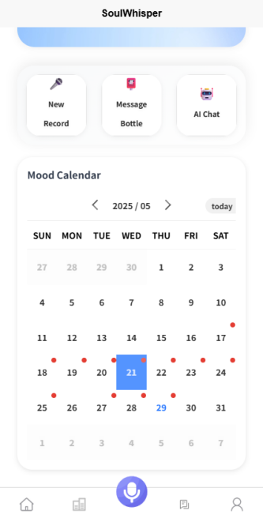 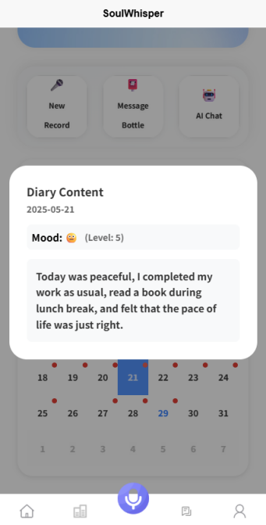

Figure 4 Select the dayFigure 5 Check diary

1. **AI emotional communication**

When you click the “AI Chat” button on the homepage, you will enter the AI psychological companion chat interface. On this page, you can freely type your emotions, concerns, or any topic you wish to share in the input box at the bottom, and then click the “Send” button to submit your message. The AI psychological companion will respond promptly based on your input, engaging in conversation to provide emotional support and psychological guidance. The entire process is smooth and straightforward, allowing you to talk to the AI at any time, receive warm companionship and professional advice, and help yourself better regulate emotions and relieve stress.

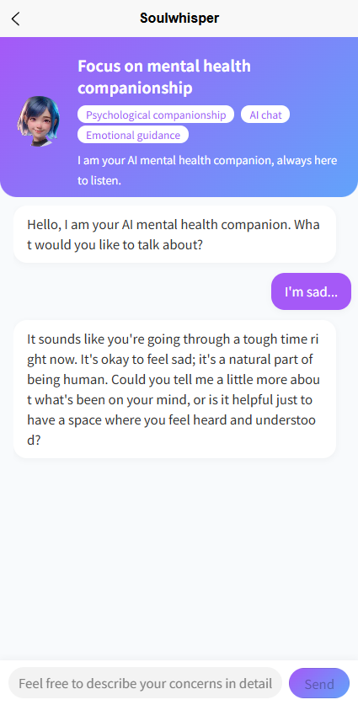

Figure 6 AI Chat

1. **Record and create your daily diary**

When you click the central recording button on the bottom taskbar of the homepage, the system will automatically navigate to the voice recording page. In its initial state, the center of the screen displays the text “WAIT FOR IT.” You can tap the microphone button below to start recording. Once recording begins, the duration will appear at the bottom of the page along with a clear “Recording...” indicator to help you track the progress. During the recording process, you can tap the red button at any time to stop. After the recording ends, the system will automatically begin converting speech to text, and a “Speech To Text...” message will appear on the screen while the conversion is in progress.

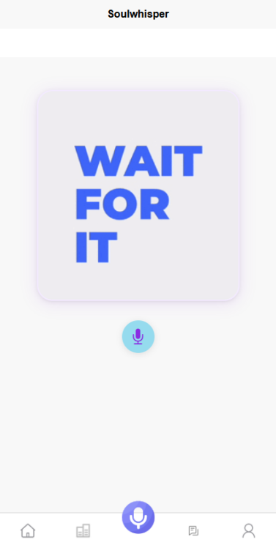 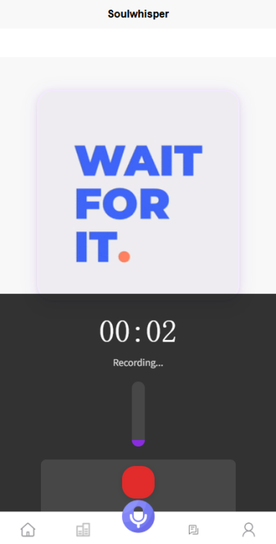

Figure 7 Record page Figure 8 Recording your voice

After the voice content is converted to text, the system will automatically navigate to the diary editing page. You can view and edit the recently recorded content in the text box. If needed, you can click the “+” button in the bottom-left corner of the page to add photos or videos, enriching your diary entry. Once editing is complete, simply click the “Publish” button in the top-right corner to post your diary.

 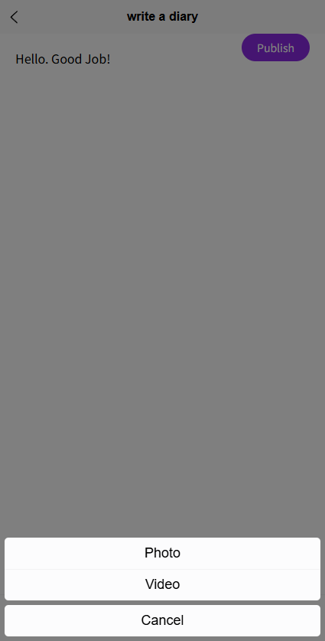

Figure 10 Diary page Figure 11 Publish your diary

After successfully publishing, you can view your newly recorded diary on the diary detail page. The system will automatically analyze and display your mood emoji and emotional intensity. After returning to the homepage, you can click on the corresponding date in the emotion calendar to review and manage your voice diaries and emotional records at any time. The entire process is smooth and straightforward, helping you efficiently record and express your daily emotions.

 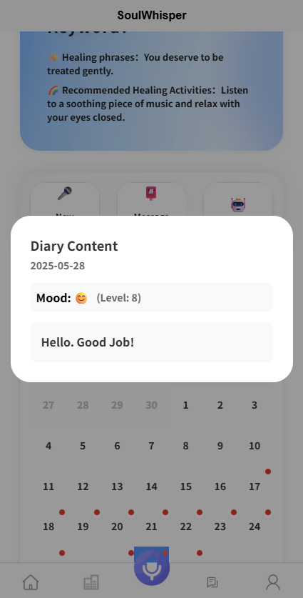

Figure 11 Diary detail Figure 12 Diary display

After completing the diary recording and publishing, if you wish to understand the emotional distribution of your recent entries, simply click the statistics button on the bottom taskbar (the chart icon located to the left of the recording button). The system will navigate to the “Weekly Emotion Report” page.

On this page, you can clearly see the “Emotional Keyword Cloud,” which highlights frequently occurring emotion-related words from your diary entries over the past week, helping you understand recent emotional themes. Below that, the “Emotion Distribution” pie chart uses different colors and percentages to clearly present the proportion of various moods—such as happiness, sadness, anger, and neutrality—in your weekly entries. These visual insights allow you to quickly grasp emotional trends throughout the week, facilitating better emotional self-management and reflection.

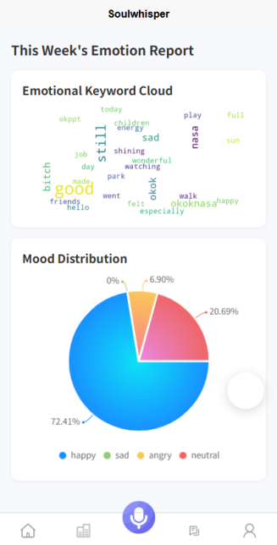

Figure 13 Week emotion show

1. **Emotional bottle post**

When you click the posts button on the bottom taskbar of the homepage, the system will navigate to the Mood Square (communication) page. On this page, you can browse various articles and posts related to emotional management and personal growth published on the platform. At the top of the page, multiple category tags are available, allowing you to filter content of interest based on tags such as “Emotional Management” and “Emotional Insight.” Each article has a favorite button on the right side—clicking it allows you to add your favorite content to your collection for easy access later. Clicking on any article will take you to the detail page, where you can read the author’s emotional journey and healing methods in depth.

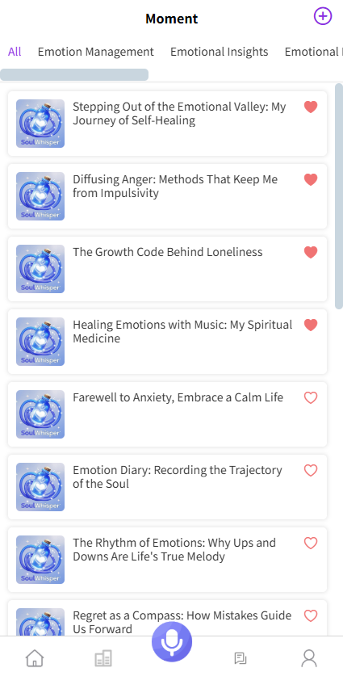 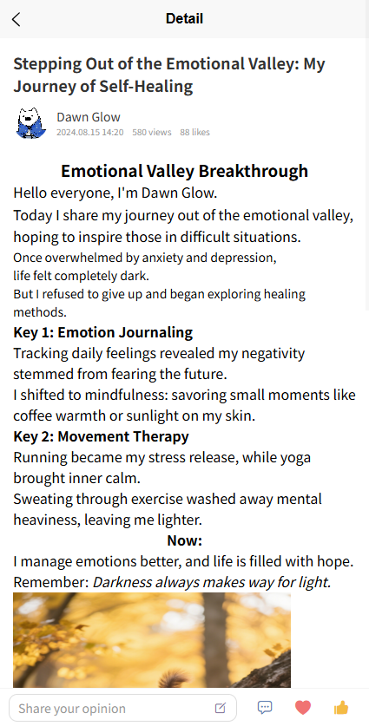

Figure 14 Emotional comment Figure 15 Detail article

You can enter your thoughts or feelings in the comment section below the article and click the “publish” button to post your comment and interact with the author and other users. The comment section supports a reply function, allowing you to respond to others’ comments and encourage more emotional exchange. The page also supports like and favorite actions, helping you save and share valuable content.

Clicking on any article will take you to the detail page, where you can read the author’s emotional journey and healing methods in depth. You can enter your thoughts or feelings in the comment section below the article and click the “publish” button to post your comment and interact with the author and other users. The comment section supports a reply function, allowing you to respond to others’ comments and encourage more emotional exchange. The page also supports like and favorite actions, helping you save and share valuable content.

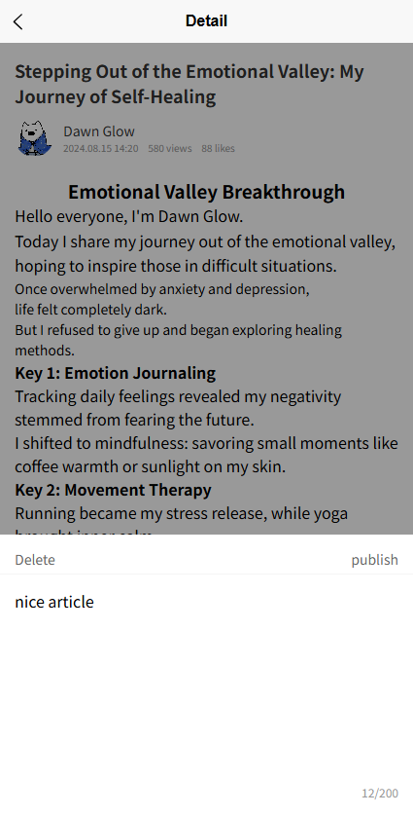 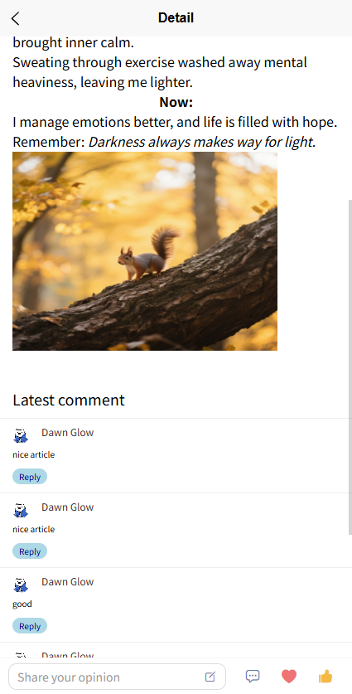

Figure 16 Publish your comment Figure 17 Comment display

1. **Profile check**

When you click the profile icon on the far right of the bottom taskbar on the homepage, the system will navigate to the Personal Center page. At the top of this page, you can view your avatar, nickname, and diary count, providing a clear overview of your personal creations and interactions. Below, you’ll see the total number of diaries you’ve published, likes received, and comments received, helping you fully understand your activity level and influence. In the middle of the page, the “Account Settings” section includes functions such as privacy settings, help center, and about us. You can manage your privacy permissions, access user support, or learn more about the platform as needed. The “Other Functions” section below supports one-click cache clearing to free up storage space, and allows you to check for app updates at any time to ensure you’re using the latest features.

At the bottom of the page, there is a “Sign Out” button, which you can click to safely log out of your account. The entire Personal Center page is clearly laid out and fully functional, making it easy for you to efficiently manage your personal information and account settings, enhancing the overall user experience.

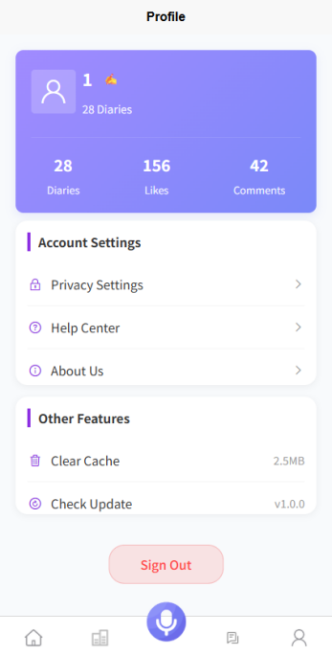

Figure 18 Profile Page